ENG 110

Claire Alexander-Joly

Your name

Semester

Banned Books and The Censorship of History

In recent years, Florida, along with other right-leaning states, passed a series of legislation regulating and restricting how Black history is taught. These include Florida’s “Stop WOKE” Act, which prohibits teaching critical race theory, and Florida’s curriculum revisions, which require teaching history in a “balanced way” by including the “benefits” of slavery and “violence perpetrated by African Americans” [10; 4]. However, not only does our political right ignore our racist history, but sometimes the left does too. This is especially apparent through the left’s admiration of *The Handmaid’s Tale*, an extremely popular piece of 1980s feminist literature that appropriates Black history to draw out sympathy for white women. Therefore, on both the political right and the left, uncomfortable history is sometimes censored and ignored for the sake of celebrating the past, a trend that has disastrous consequences.

Most Americans agree that studying history in full is exceptionally important. In a 2020 national survey of more than 1,800 people, over 70% of Republicans and Democrats responded that it is acceptable for the teaching of history to “cause discomfort” [3]. The importance of history is clear: to not make the same mistakes as people in the past, we need to know what happened and understand the ideologies that caused events, especially events horrific enough to cause students to feel discomfort.

In a hearing on critical race theory being taught in the U.S. military, Joint Chiefs of Staff Chairman Mark Milley defended the practice, saying that just like reading Karl Marx or Lenin doesn’t make someone Communist, learning about critical race theory does not indoctrinate those in the military. He also responded to the mention of a class on “understanding whiteness and white rage,” saying that even he, who is white, wants to understand it and find out what caused the insurrection at the Capitol on January 6th [7]. This understanding is necessary for our military to defend us, but also for the U.S. to have an informed public that will act and vote to reduce atrocities like racial discrimination rather than increase them or ignore them.

Unfortunately, in recent years Florida and other Republican-controlled states have passed legislation that prohibits teaching that presumably causes students psychological discomfort. What is motivating conservatives to ignore our uncomfortable history when there is a significant majority support for teaching it?

When Florida’s Governor Ron DeSantis signed the “Stop WOKE” Act in April 2022, which prohibited lessons that cause white students to “feel guilt, anguish, or other forms of psychological distress” because of the past, he said: “We are not gonna use your tax dollars to teach our kids to hate this country or to hate each other” [10]. To celebrate our country’s history, DeSantis and many Floridians are willing to censor uncomfortable topics in our country’s history like the horrors of slavery and the racial injustice that continues to this very day. This helps explain why censorship of Black history is much more prevalent in right-leaning states: when asked whether history should celebrate or question the nation’s past, 84% of Republicans said history should celebrate it versus 30% of Democrats [3]. The decision to not question our nation’s history and ignore uncomfortable truths because it makes our history easier to celebrate has disastrous consequences.

In the 2022-2023 school year, over 3,000 books were banned across the country: 88% of book bans occurred in Republican-leaning districts and 30% of the books banned contained characters of color or themes of race and racism. More than 1,400 of the bans occurred in Florida alone [12]. Some of the books banned include *Beloved* by Toni Morrison, a book based on a historical account of a woman’s attempt to escape slavery in the 1850s, and *The Hate U Give* by Angie Thomas, a young adult novel inspired by the Black Lives Matter movement and the murder of Oscar Grant and other African Americans by the police [8,13]. Florida has even banned certain math textbooks because they reference “racial prejudice” [5].

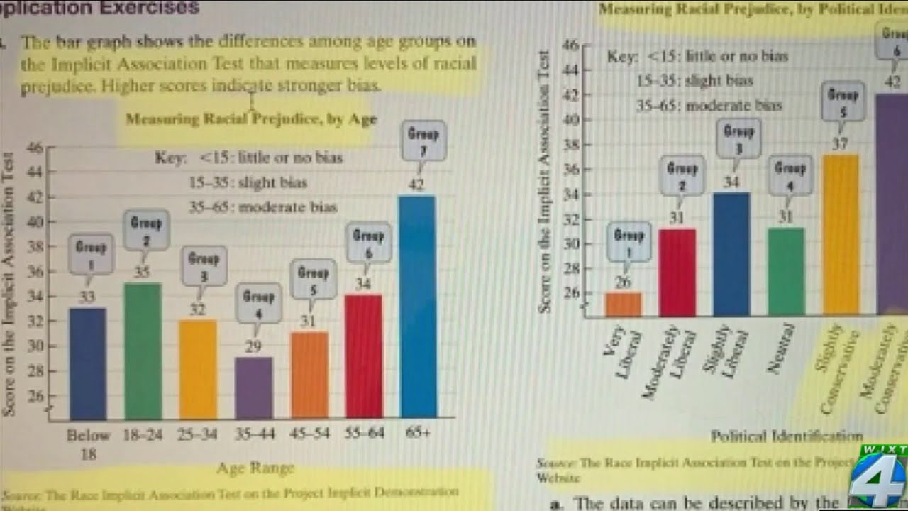

*Fig. 1 [citation]*

If students are prevented from reading books that address racial discrimination in our nation’s past and its present, they will lack the knowledge to combat racial injustice today.

However, Florida’s censorship of history goes beyond just literature: It impacts all public school teaching, even at the university level. The Florida Department of Education also rejected the College Board’s new AP African American studies course saying that it “lacks educational value” [11]. College Board’s AP classes, including AP African American studies, are considered by most colleges and universities in the U.S. to have enough educational value to count for college credits despite being a high school course.

Professor Marvin Dunn is the leader of the nonprofit “Teach the Truth,” an organization that gives high school students educational tours of where Florida’s worst racial violence occurred. Teaching about these events can now cause public school teachers to lose their certification if their lesson causes students “psychological distress” because of the “Stop WOKE” Act. This prevents Florida’s students from learning the full history of their state and the nation, instead giving them a whitewashed version that ignores the centuries of racial discrimination against Black people in the United States—for the sake of feeling better about our country’s history [11].

While the political right wants to celebrate America uncritically, the political left instead celebrates more recent ideologies such as those put forth in the Black Lives Matter, the feminist and Pride movements. How does the left approach racism in the history of these movements?

*The Handmaid’s Tale* by Margaret Atwood has been one of the most popular and important pieces of feminist literature since its release in 1985. The book imagines the United States after a coup by a far-right theocracy forced women into slavery, which leads to them being valued only for their ability to bear children. The women who are still fertile despite environmental toxins are called handmaids, and they are forced to have sex and give birth to the families of the ruling class. They are also forced to cover their faces with a white bonnet and bodies with a red cloak—to prevent others from seeing their face [1].

With the increasing pressure on women’s right to an abortion since the election of Donald Trump in 2016 and the book’s TV adaptation in 2017, *The Handmaid’s Tale* has become increasingly important to the politics of the left. According to *BBC News*, “Handmaid costumes even became common at protests of laws intended to limit women’s reproductive freedom” [1].

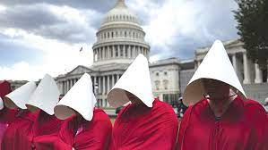

*Fig. 2 [citation]*

In addition, the phrase from the book, “Nolite te bastardes carborundorum,” meaning “Don’t let the bastards grind you down,” has become a rallying cry that many feminists have tattooed on their bodies [1]. Furthermore, after *The Handmaid’s Tale* was banned in Florida, Texas, and other republican states, Margaret Atwood collaborated with PEN America, a nonprofit that advocates for free expression, to make an unburnable version of her book and raise money to fight against book bans [9].

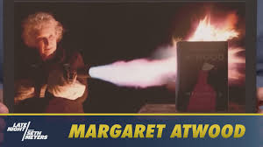

*Fig. 3 [citation]*

When speaking about the unburnable book, PEN America’s CEO, Suzanne Nossel, said, “In the face of a determined effort to censor and silence, this unburnable book is an emblem of our collective resolve to protect books, stories, and ideas from those who fear and revile them” [9]. All these references to *The Handmaid’s Tale* reveal how important it is to the political left, especially in its campaigns to legalize abortion and stop book banning.

However, *The Handmaid’s Tale* is not perfect. The book contains only white characters, despite the frequent references to slavery when describing the situation of white women in the book. These references include the “Underground Femaleroad,” handmaids not being allowed to read, and the regime hating the song “Amazing Grace,” which protested the slave trade [2]. Appropriation of Black history to create a story about white people's suffering ignores and erases the atrocities faced by people of color in the United States. Atwood does justify the book’s lack of Black people, writing in a news report in the story that the regime resettled the “Children of Ham,” a Biblical reference to the peoples of Africa [2]. While this explains why there are no Black people in the book, it does not justify Atwood’s decision to write a book about oppression that ignores the oppression of African Americans. As Noah Berlatsky put it, “Atwood critiques the regime, but also collaborates with it to push Black people aside” [2].

*The Handmaid’s Tale’s* exclusion of Black people is not unique. Rather, it mirrors the exclusion of Black people in second-wave feminism. Second-wave feminism started in 1963, with the release of Betty Friedan’s *The Feminine Mystique* and lasted until the mid-1980s, around when *The Handmaid’s Tale* was published.Just as the main character of *The Handmaid’s Tale* is a white and college-educated woman, the movement was dominated by well-educated white women. Also, just as the book excludes people of color, second-wave feminism alienated Black and Latinx women by excluding them and ignoring the atrocities that had been committed against them such as forced sterilization [6]. Because *The Handmaid’s Tale* contains the racism of the second-wave feminism movement, it acts as a history of the uncomfortable past of feminism in the United States.

When Hulu adapted the book into a TV show, how did they handle this uncomfortable history? Did they confront it or did they ignore it and whitewash it like Florida and other states have with U.S. history?

In the 2017 TV adaptation of *The Handmaid’s Tale*, many of the characters are Black. This includes the main character’s husband, best friend, and child. In many of the scenes those characters take part in, the allusions to Black history avoid cultural appropriation and erasure because the characters are Black themselves. However, the makers of the show fail to address the exclusion of Black people from the original book or racism directly. As Noah Berlatsky put it, the regime is “*less* racist than the current United States.” The show also never confronts American slavery or Black oppression directly, and the main character is still white to draw sympathy from the audience [6]. It fails to properly address *The Handmaid’s Tale’s* appropriation of Black history and whitewashes the history of the book by ignoring the exclusion of people of color in the original book. By extension, the political left embracing and celebrating *The Handmaid’s Tale* without addressing the book’s exclusion of people of color whitewashes the history of the book, feminism, and the political left as a whole.

Obviously, the scope and impact of the right ignoring the racism in U.S. history is much larger than the left ignoring the racism in *The Handmaid’s Tale*. However, that isn’t the point. The point is that whether we are Republicans or Democrats, right-leaning or left-leaning, we *can* make the mistake of ignoring and even censoring uncomfortable history when it comes to the things we celebrate. By recognizing that we are fallible in this way we can begin to identify and correct the places where we ignore and whitewash history.

Works Cited

1. Armstrong, Jennifer Keishin. “Why the Handmaid’s Tale Is So Relevant Today.” *BBC Culture*, BBC, 24 Feb. 2022, www.bbc.com/culture/article/20180425-why-the-handmaids-tale-is-so-relevant-today.
2. Berlatsky, Noah. “Both Versions of the Handmaid’s Tale Have a Problem with Racial Erasure.” *The Verge*, 15 June 2017, [www.theverge.com/2017/6/15/15808530/handmaids-tale-hulu-margaret-atwood-black-history-racial-erasure](http://www.theverge.com/2017/6/15/15808530/handmaids-tale-hulu-margaret-atwood-black-history-racial-erasure).
3. Burkholder, Pete, and Dana Schaffer. “A Snapshot of the Public’s Views on History: National Poll Offers Valuable Insights for Historians and Advocates.” *Home*, 30 Aug. 2021, [www.historians.org/research-and-publications/perspectives-on-history/september-2021/a-snapshot-of-the-publics-views-on-history-national-poll-offers-valuable-insights-for-historians-and-advocates](http://www.historians.org/research-and-publications/perspectives-on-history/september-2021/a-snapshot-of-the-publics-views-on-history-national-poll-offers-valuable-insights-for-historians-and-advocates).
4. Chavez, Nicole. “Florida Board of Education Approves New Black History Standards That Critics Call ‘a Big Step Backward.’” *CNN*, Cable News Network, 20 July 2023, [www.cnn.com/2023/07/20/us/florida-black-history-education-standards-reaj/index.html](http://www.cnn.com/2023/07/20/us/florida-black-history-education-standards-reaj/index.html).
5. Croft, Jay, and Steve Contorno. “Florida Releases 4 Examples from Math Textbooks It Rejected for Public Schools.” *CNN*, Cable News Network, 22 Apr. 2022, [www.cnn.com/2022/04/22/us/florida-math-textbooks-critical-race-theory-examples](http://www.cnn.com/2022/04/22/us/florida-math-textbooks-critical-race-theory-examples).
6. Jain, Neeti. “White Feminism - How Feminist Movements Failed to Be Inclusive – in Diverse Company White Feminism.” In Diverse Company, 10 Mar. 2021, [www.indiversecompany.com/white-feminism-how-feminist-movements-failed-to-be-inclusive/](http://www.indiversecompany.com/white-feminism-how-feminist-movements-failed-to-be-inclusive/).
7. Kurtzleben, Danielle. “Top General Defends Studying Critical Race Theory in the Military.” *NPR*, NPR, 23 June 2021, [www.npr.org/2021/06/23/1009592838/top-general-defends-studying-critical-race-theory-in-the-military](http://www.npr.org/2021/06/23/1009592838/top-general-defends-studying-critical-race-theory-in-the-military).
8. Martin, Jennifer. “The 50 Most Banned Books in America.” *CBS News*, CBS Interactive, 17 Nov. 2022, www.cbsnews.com/pictures/the-50-most-banned-books-in-america/35/.
9. Mufarech, Antonia. “Margaret Atwood Tried-and Failed- to Burn a Copy of ‘The Handmaid’s Tale.’ Here’s Why.” Smithsonian.Com, Smithsonian Institution, 9 June 2022, [www.smithsonianmag.com/smart-news/margaret-atwood-tried-and-failed-to-burn-copy-handmaids-tale-unburnable-fireproof-180980223/](http://www.smithsonianmag.com/smart-news/margaret-atwood-tried-and-failed-to-burn-copy-handmaids-tale-unburnable-fireproof-180980223/).
10. Natanson, Hannah. “All the Ways Ron DeSantis Is Trying to Rewrite Black History.” *The Washington Post*, WP Company, 26 July 2023, [www.washingtonpost.com/education/2023/07/24/desantis-florida-black-history/](http://www.washingtonpost.com/education/2023/07/24/desantis-florida-black-history/).
11. Rozsa, Lori. “A Black Professor Defies Desantis Law Restricting Lessons on Race.” *The Washington Post*, WP Company, 30 Jan. 2023, [www.washingtonpost.com/nation/2023/01/21/florida-black-history-ron-desantis/](http://www.washingtonpost.com/nation/2023/01/21/florida-black-history-ron-desantis/).
12. “School Book Bans: The Mounting Pressure to Censor.” PEN America, 4 Oct. 2023, pen.org/report/book-bans-pressure-to-censor/.
13. Velshi, Ali. “Why ‘The Hate U Give’ Is on Book Ban Lists.” MSNBC, NBCUniversal News Group, 28 July 2023, [www.msnbc.com/ali-velshi/-hate-u-give-book-ban-lists-rcna96251](http://www.msnbc.com/ali-velshi/-hate-u-give-book-ban-lists-rcna96251).